Start on top line, use Arial 14-pt font for the title, which should be in bold (upper and lower) case and centered.

Presenting Author’s First Name and Surname underlinedª and Author’s First Name and Surname^{b}

ªReplace this text with authors’ affiliation
^{b}If more than one affiliation is needed, they should be indicated by superscript
letters, a, b, etc as shown above

The document is to be submitted in .pdf. Single line space should be used in entire document.The entire abstract can not exceed 1 page, including text and figures. Use A4 paper size with vertical layout. Leave 2.5 cm margins on all sides of the page. Use Arial 12.Put references in the text in brackets [1].

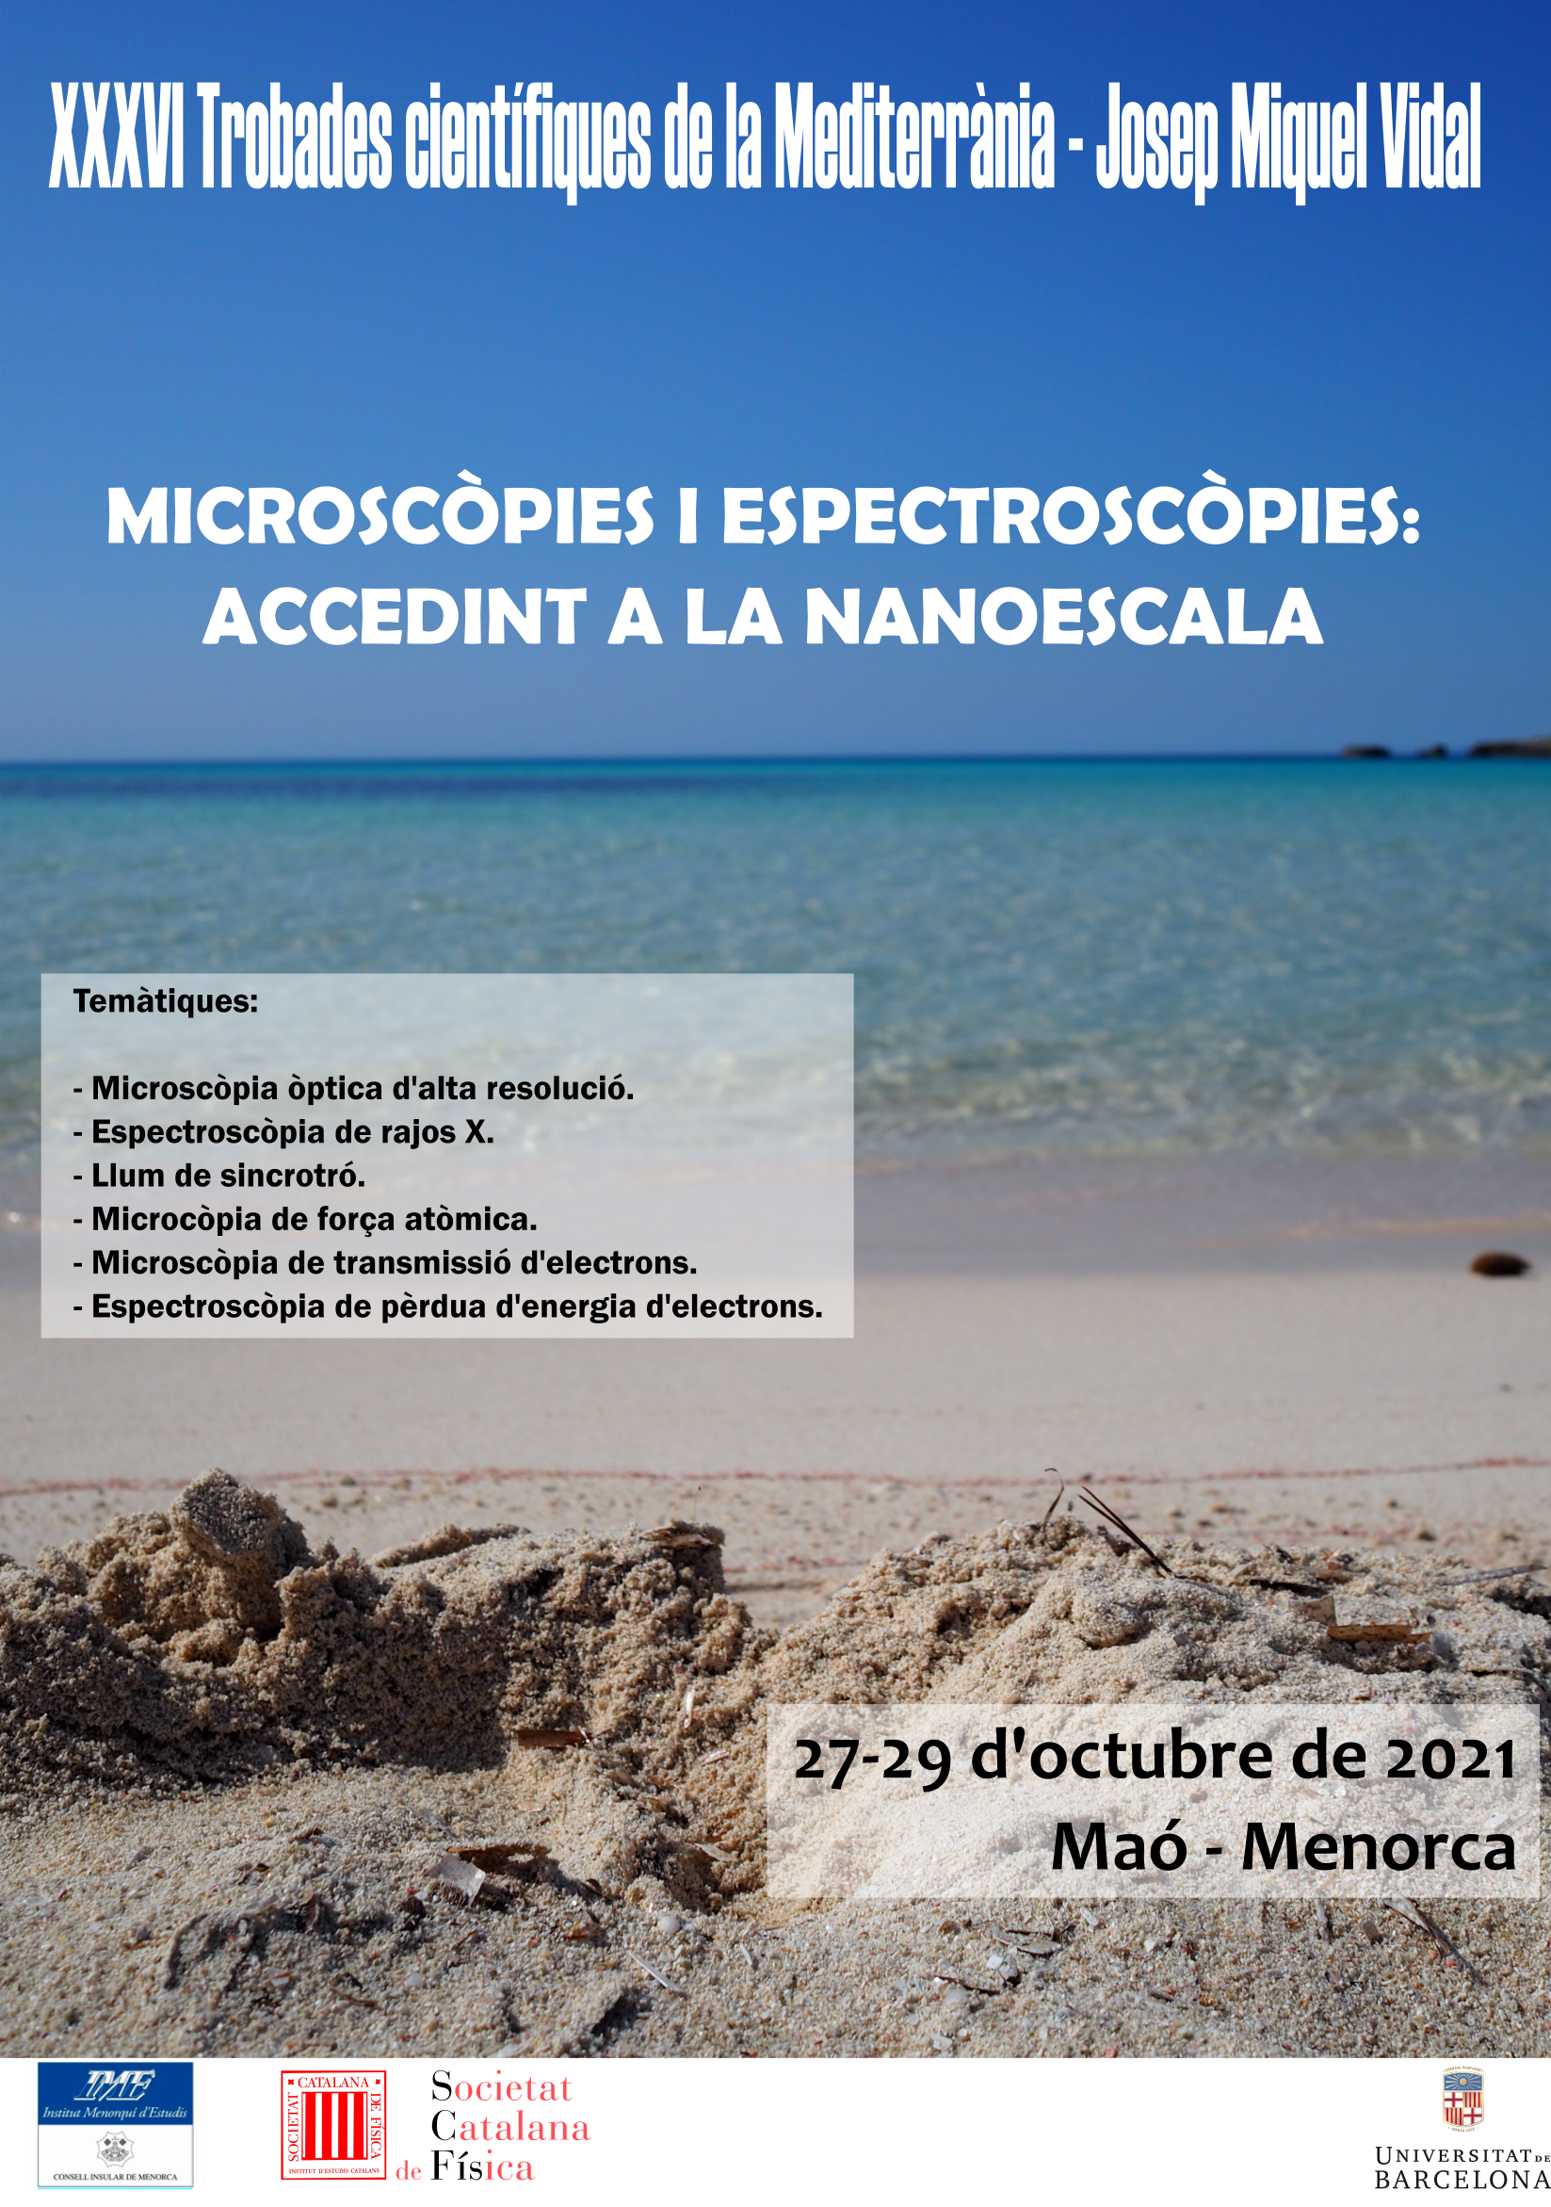

FIGURE 1. This is Style for Figure Captions. All text should be 10 pt. The text “FIGURE 1” which labels the caption should be bold and capital. Center this text under the figure. If figures have more than one part, there should be labels (a), (b), etc.

References

[1] Reference 1
[2] Reference 2

